**Quiz**

1. Read the word and select the picture.

hill

|  |  |  |
| --- | --- | --- |
| o | o | o |

2. Listen to the word, say it and spell it.

_________________

3. Listen to the word. What is the final sound?

|  |  |  |  |
| --- | --- | --- | --- |
|  | o | o | o |

4. Listen to the teacher and write the phrase:

5. Finish the spelling.

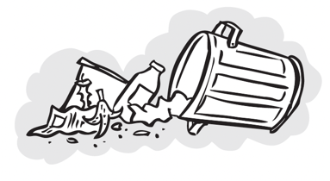 m e __